**Dietary Requirements and Allergens**

Our food has Food for Life accreditation showing that:

* Our food is sourced locally
* Our meat is Red Tractor assured, meaning it’s safe and produced locally
* Our fish is certified by the Marine Stewardship Council
* Our meals are healthy, nutritious balanced and also low in fat, sugar and fat

Special diets are extremely important to us. We work with each school to ensure the special diet process is effective, reassuring you that children with allergies or intolerances can eat safely with us.

**Our Food**

**Free School Meals**

We are proud to serve healthy, balanced and freshly prepared school meals. Our meals give children all the energy they need to power through the day, helping them concentrate at school and supporting their wellbeing.

Universal Infant Free School Meals can save parents up to £487 per year. School meals are free for children in reception, year 1 and year 2. Ask for school meals at your school office.

If you are in receipt of benefits you may be entitled to continue having Free School Meals. Check your eligibility and apply at <https://www.gov.uk/apply-free-school-meals>

**Healthy Eating**

**About your children’s School Meals**

We are Eat Culture Education Catering, the caterer at your school and the largest provider in Nottingham.

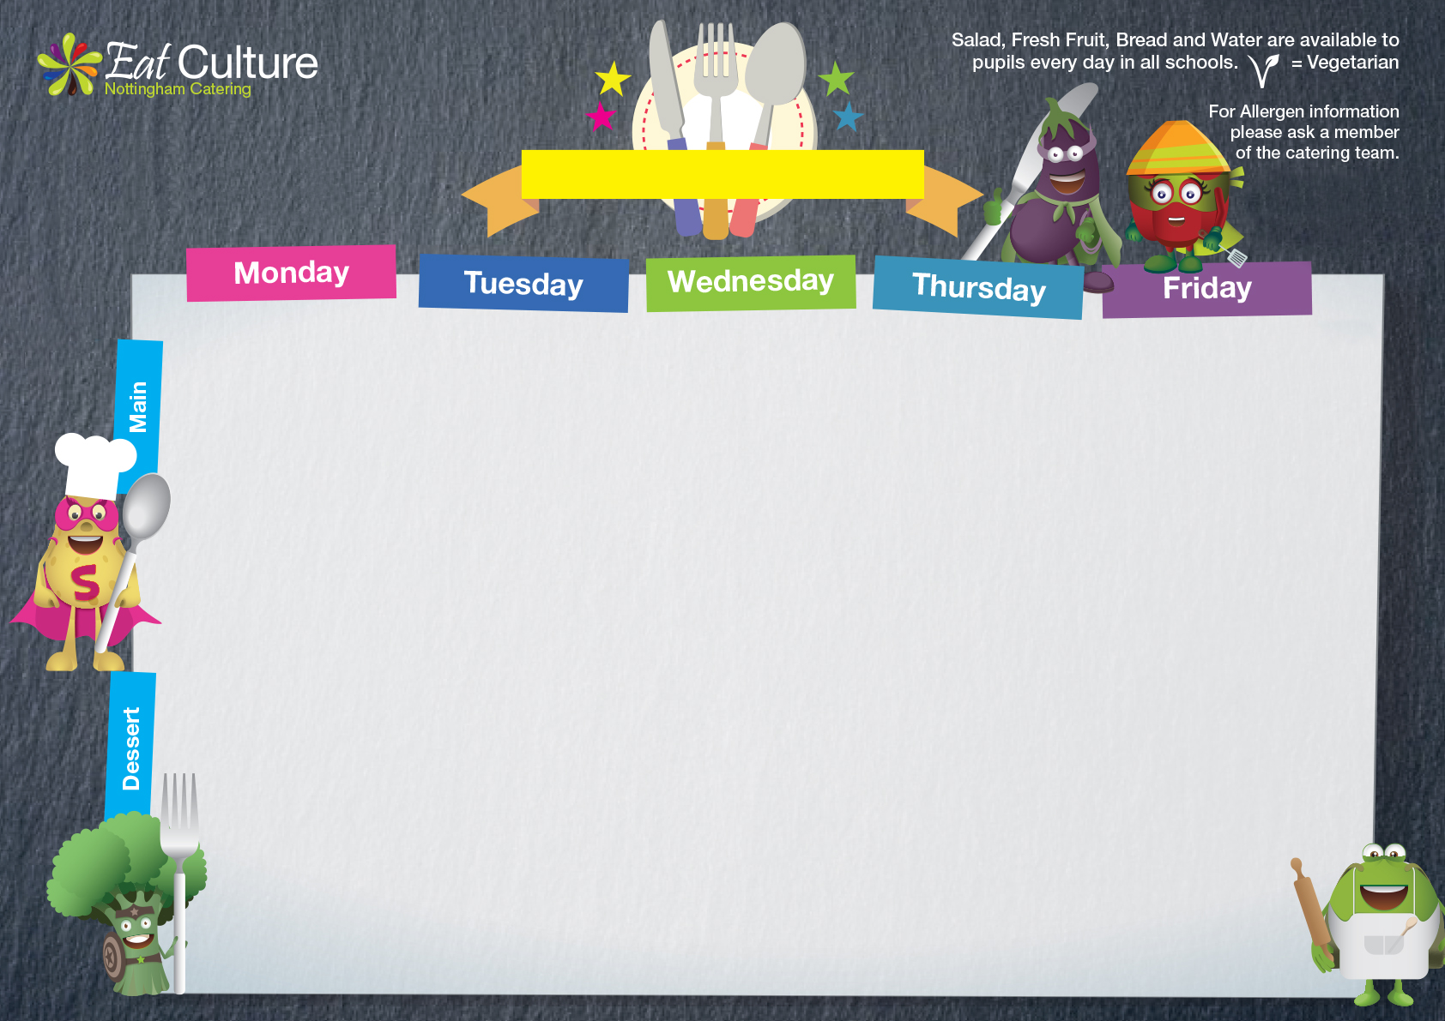

**Unity**

Week: 1

Date: 19th February, 11th March, 15th April, 6th May

3rd June, 24th June, 15th July



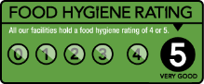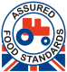

MSC-C-54995 ‘Seafood with this mark comes from an MSC certified sustainable fishery. [www.msc.org](http://www.msc.org)’

Roast Chicken & Stuffing with gravy

New Potatoes

Vegetable Medley

Quorn Roast & Stuffing with gravy

New Potatoes

Vegetable Medley

Jacket with Cheese or Tuna Mayonnaise and Salad

Mandarin Muffin

Milk

Fresh Fruit Salad

Beef Bolognaise with Baguette Slice &

Seasonal Vegetables

Jacket Potato with Cheese & Salad

Jacket Potato with Tuna Mayonnaise and Salad

Flapjack with Raisins

Milk

Fresh Fruit Salad

Fish Fingers with Oven Chips and

Peas

Fishless Finger with Oven Chips and Peas

Jacket with Cheese or Tuna Mayonnaise and Salad

Chocolate Shortbread Slice with Milk

Fresh Fruit Salad

Sausage, Mashed Potatoes, Baked Beans

Veggie Sausage, Mashed Potatoes, Baked Beans

Jacket with Cheese or Beans and Salad

Chocolate Sponge & Chocolate Custard

Fresh Fruit Salad

Cheese & Tomato Pizza, Diced Potatoes

Carrot Sticks or Sweetcorn

Tomato & Basil Pasta with Baguette Slice & Salad

Jacket with Cheese or Tuna Mayonnaise and Salad

Shortbread Cookie

Fresh Fruit Salad



Week: 2

Date: 26th February, 18th March, 22nd April, 13th May,

10th June, 1st July, 22nd July

**Unity**





MSC-C-54995 ‘Seafood with this mark comes from an MSC certified sustainable fishery. [www.msc.org](http://www.msc.org)’

Roast Pork &

Mashed Potatoes, Gravy

Vegetable Medley

Quorn Roast & with gravy

Mashed Potatoes

Vegetable Medley

Jacket with Cheese or Tuna Mayonnaise and Salad

Marble Cake & Custard

Fresh Fruit Salad

BBQ Chicken with

½ Jacket Potato & Seasonal Vegetables

Cheese & Tomato Pizza,

½ Jacket Potato

Sweetcorn or Seasonal Vegetables

Jacket with Cheese or Tuna Mayonnaise and Salad

Jelly & Fruit

Fresh Fruit Salad

Homemade Sausage Roll served with New Potatoes & Baked Beans

Veggie Sausage with New Potatoes & Baked Beans

Jacket Potato served with Baked Beans & Cheese

Apple Crumble Muffin

Milk

Fresh Fruit Salad

Fish Portion

Oven Chips with Seasonal Vegetables

Veggie Balls served with Oven Chips, Gravy & Seasonal Vegetables

Jacket with Cheese or Tuna Mayonnaise and Salad

Chocolate Brownie

Milk

Fresh Fruit Salad

Beef Cottage Pie served with Gravy and Seasonal Vegetables

Cheese & Onion Roll served with Diced Potatoes & Seasonal Vegetables

Jacket with Cheese or Tuna Mayonnaise and Salad

Oaty Cookie

Fresh Fruit Salad

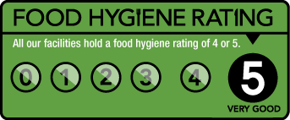



Week: 3

Date: 4th March, 25th March, 29th April, 20th May,

17th June, 8th July

**unity**



MSC-C-54995 ‘Seafood with this mark comes from an MSC certified sustainable fishery. [www.msc.org](http://www.msc.org)’

Chicken Pie with Mashed Potatoes

Seasonal Vegetables

Savoury Veggie Mince Pie served with Mashed Potatoes &

Gravy Seasonal Vegetables

Jacket with Cheese or Tuna Mayonnaise and Salad

Lemon Drizzle Cup Cake

Milk

Fresh Fruit Salad

Salmon Fish Fingers with Oven Chips

Baked Beans

Fish Fingers with Oven Chips

Baked Beans

Jacket with Cheese or Tuna Mayonnaise and Salad

Chocolate Orange Cookie

Fresh Fruit Salad

Roast Pork

Stuffing & Gravy

Roast Potatoes

Vegetable Medley

Quorn Roast

Stuffing & Gravy

Roast Potatoes

Vegetable Medley

Jacket with Cheese or Tuna Mayonnaise and Salad

Angel Delight with Fruit

Fresh Fruit Salad

Cheese & Tomato Pizza,

Salad

Veggie Sausage Pasta served with Baguette Slice & Salad

Jacket with Cheese or Tuna Mayonnaise and Salad

Sticky Toffee Pudding & Custard

Fresh Fruit Salad

Pork Sausage Casserole with

New Potatoes & Seasonal Vegetables

Cheese Flan served with New Potatoes & Seasonal Vegetables

Jacket with Cheese or Tuna Mayonnaise and Salad

Jam Crumble Bar

Fresh Fruit Salad

